PAVENDAR BHARATHIDASAN COLLEGE OF ENGINEERING & TECHNOLOGY
(Approved by AICTE, Affiliated to Anna University, Chennai) Trichy, Tamil Nadu, India



SMARTINTERNZ GUIDED PROJECT REPORT
“GARAGE MANAGEMENT SYSTEM”
Submitted by:
Department: Computer Science and Engineering

Name: Darneshwaran.R
Register Number: [813122104012]

Name: Santhosh.G
Register Number: [813122104046]

Name: Divyan.A
Register Number: [813122104017]

Name: Bharath.K
Register Number: [813122104006]

Name: Mukesh.S
Register Number: [813122104033]

Abstract
The Garage Management System (GMS) is a cloud-based application developed using Salesforce Admin and Developer tools to optimize operations in automotive repair facilities. It addresses key challenges such as managing customer data, tracking vehicle service history, scheduling appointments, handling inventory, and generating invoices—all within a unified platform.
By automating routine tasks and centralizing service workflows, GMS enhances operational efficiency, reduces manual errors, and improves customer satisfaction. Its intuitive interface ensures ease of use for garage staff, while its scalable design supports growth and adaptability in a competitive market.
This project was undertaken as part of the SmartInternz Guided Project Program, offering practical exposure to CRM development and real-world business problem-solving. The system reflects a strong understanding of service-oriented architecture and demonstrates the potential of Salesforce in transforming traditional service models into streamlined digital solutions.

Objectives
The primary objectives of the Garage Management System (GMS) project are:
- 🛠️ Streamline Garage Operations: Automate key processes such as customer registration, vehicle service tracking, appointment scheduling, and billing.
- 📊 Centralize Data Management: Maintain a unified database for customer details, vehicle history, and service records to improve accessibility and reduce manual errors.
- ⏱️ Enhance Efficiency: Reduce time spent on administrative tasks and improve workflow through a user-friendly interface and real-time data access.
- 🤝 Improve Customer Experience: Provide transparent service updates, faster turnaround times, and better communication to build long-term customer relationships.
- ☁️ Leverage Salesforce Capabilities: Utilize Salesforce Admin and Developer tools to build a scalable, cloud-based CRM solution tailored for garage operations
- 📈 Support Business Growth: Enable small and mid-sized garages to modernize their systems and remain competitive in a rapidly evolving market.

Features of the System
The Garage Management System (GMS) offers a range of features designed to enhance the efficiency and transparency of garage operations. Key features include:
- 🧾 Customer Management: Store and manage customer profiles, contact details, and service history for personalized service and follow-ups.
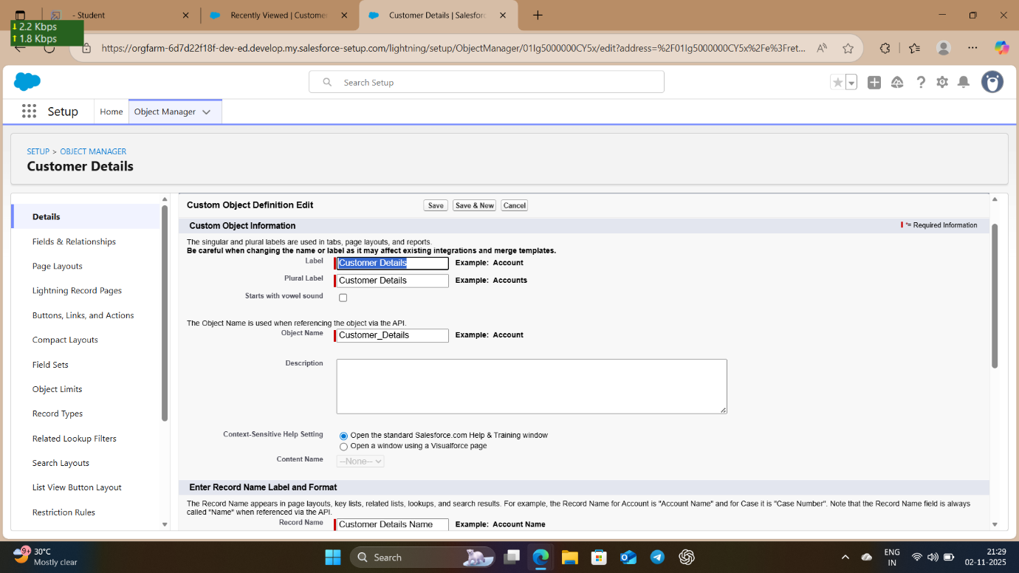

- 🚗 Vehicle Service Tracking: Maintain detailed records of each vehicle’s service history, including repairs, parts replaced, and technician notes.
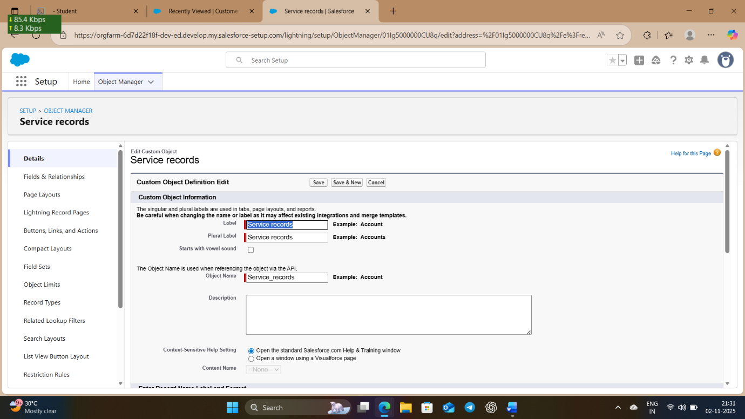
- 📅 Appointment Scheduling: Allow customers to book service appointments online and enable staff to manage schedules efficiently. 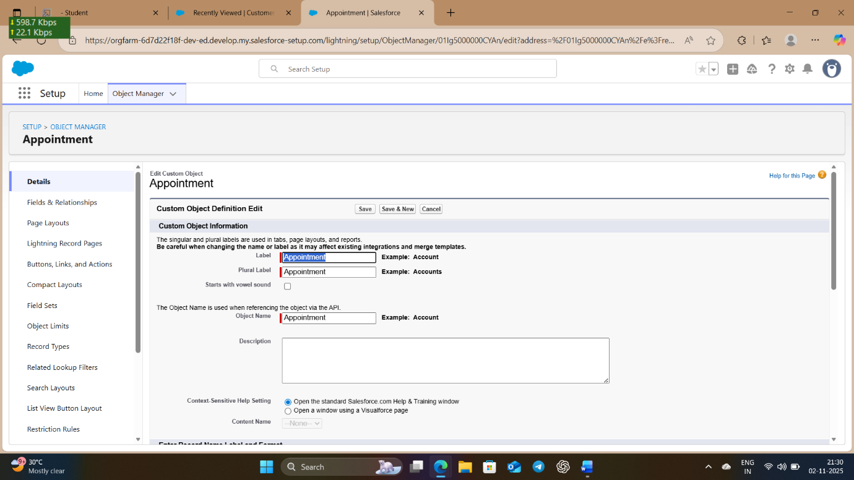

- 💳 Billing and Invoicing: Generate accurate service bills and invoices automatically, with options for discounts, taxes, and payment tracking. 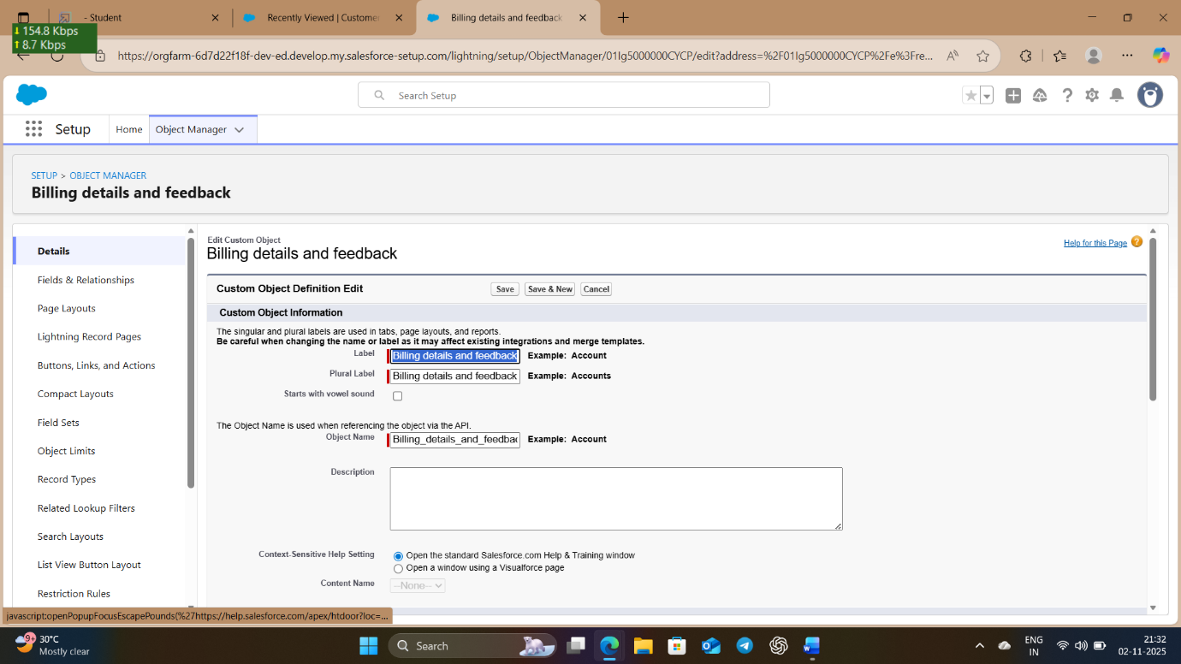
- 📈 Dashboard and Reports: Visual dashboards for garage owners and managers to monitor performance metrics, service trends, and revenue

Conclusion
The Garage Management System (GMS) project successfully demonstrates the application of Salesforce technologies to solve real-world challenges in the automotive service industry. By integrating features such as customer management, service tracking, appointment scheduling, and billing, the system streamlines garage operations and enhances overall efficiency.
Developed as part of the SmartInternz Guided Project Program, this solution reflects a practical understanding of CRM development and cloud-based application design. The project not only improved technical skills in Salesforce Admin and Developer tools but also emphasized the importance of user-centric design and process automation.
In conclusion, the GMS provides a scalable and efficient platform for garages to modernize their workflows, improve customer satisfaction, and stay competitive in a rapidly evolving market.

